**TRAFFIC MANAGEMENT SYSTEMS**

* **Describe the project's objectives, IOT sensor setup, mobile app development, Raspberry Pi integration, and code implementation.**
* **Include diagrams, schematics, and screenshots of the IOT sensors and mobile app.**
* **Explain how the real-time traffic monitoring system can assist commuters in making optimal route decisions and improving traffic flow.**

**OBJECTIVES:**

Traffic control has as its principal objective to manage the movement of people and goods as efficiently and safely as possible. The dual objectives, however, frequently conflict or, at least, compete.

The Smart Traffic Management System aims to improve traffic flow, safety, and reduce congestion in urban areas by leveraging IOT technology and data-driven solutions. The project's specific objectives include:

* **Traffic Monitoring**: Monitor traffic conditions, including vehicle density, speed, and congestion in real-time.
* **Adaptive Traffic Control**: Implement smart traffic signals that adjust their timing based on current traffic conditions to optimize traffic flow.
* **Incident Detection**: Detect and respond to accidents, roadblocks, or other incidents promptly to minimize disruption.
* **Mobile App for Drivers**: Develop a mobile app to provide drivers with real-time traffic information, navigation assistance, and alerts about road conditions.

**IOT SENSOR SETUP:**

The IOT sensor setup for the Smart Traffic Management System will include various sensors and devices to monitor traffic conditions:

* **Traffic Cameras**: Deploy cameras at key intersections and roadways to capture real-time images and video footage for traffic monitoring and incident detection.
* **Vehicle Detection Sensors**: Use sensors like inductive loops, ultrasonic sensors, or cameras with object detection to monitor vehicle presence, speed, and traffic density.
* **Weather Sensors**: Monitor weather conditions like rain, snow, or fog, as adverse weather can impact traffic flow and road safety.
* **GPS and Mobile Data**: Gather real-time location data from GPS devices and mobile phones to track vehicle movements and identify traffic congestion.

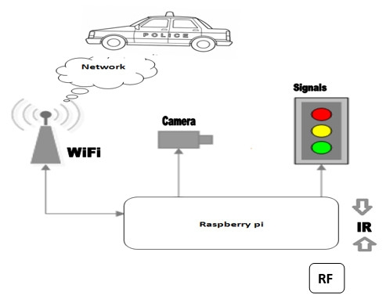

**MOBILE APP DEVELOPMENT:**

The mobile app for the Smart Traffic Management System will be available on both IOS and Android platforms and provide the following features for drivers:

* **Real-time Traffic Updates**: Display real-time traffic conditions, congestion, and incident reports.
* **GPS Navigation:** Provide turn-by-turn navigation with real-time traffic data to help drivers find the fastest route .Incident Alerts: Notify users of accidents, road closures, or other incidents along their route.
* **Traffic Signal Predictions:** Display predicted waiting times at traffic signals, helping drivers plan their approach.
* **Route Recommendations**: Suggest alternative routes to avoid congestion or incidents.

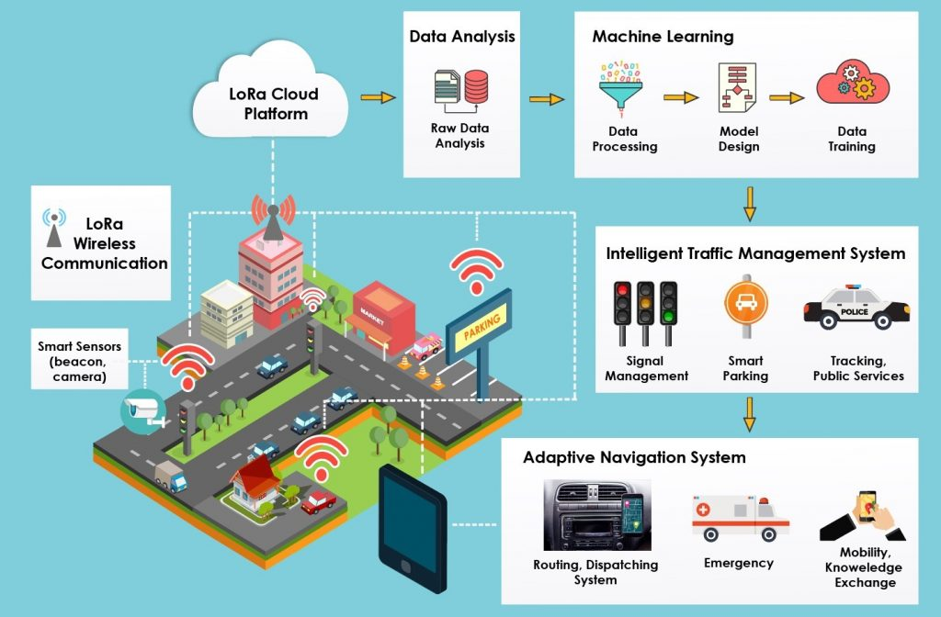

**RASPBERRY PI INTEGRATION:**

The Raspberry Pi serves as the central hub, processing data from sensors and communicating with traffic control systems and the mobile app. It uses Wi-Fi and other communication protocols to collect data and control traffic signals.

Raspberry Pi will serve as a central hub for data aggregation, processing, and communication in the Smart Traffic Management System. Integration with the Raspberry Pi will involve the following:

* **Sensor Connectivity**: Connect traffic cameras, vehicle detection sensors, and weather sensors to the Raspberry Pi for data collection.
* **Data Processing**: Process sensor data locally on the Raspberry Pi to analyze traffic conditions and detect incidents.
* **Communication**: Establish a communication link between the Raspberry Pi and the mobile app to provide real-time traffic updates to users.
* **Traffic Signal Control**: Connect traffic signal controllers to the Raspberry Pi for adaptive traffic signal control based on real-time traffic data.

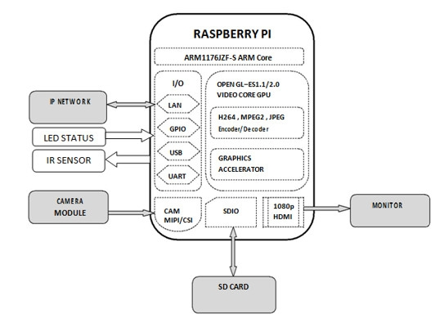

**CODE IMPLEMENTATION:**

Code implementation in a traffic management system involves the development of software to collect, process, and utilize data from IoT sensors, control traffic signals, and provide real-time information to commuters. Below are some key components and code examples for a simple traffic management system. Please note that this is a basic illustration, and real-world systems are more complex.

The code implementation for the Smart Traffic Management System will involve a variety of programming languages and libraries tailored to the specific components:

* **Python for Raspberry Pi:** Write Python scripts for data collection, data analysis, and traffic signal control.
* **Mobile App Development:** Develop a native mobile app for IOS and Android using languages like Swift, Java and appropriate development frameworks.
* **Image and Video Processing:** Utilize image and video processing libraries for analyzing traffic camera footage and incident detection.
* **GPS Integration:** Integrate GPS services and APIs for real-time location tracking and navigation features in the mobile app.
* **Cloud Services:** Implement cloud-based solutions for data storage, analytics, and scalability as needed.
* **Security:** Ensure data security and privacy in both data transmission between the mobile app and the Raspberry Pi and data storage.

The code will be structured to ensure modularity, scalability, and maintainability throughout the project's development and deployment phases. Regular testing and debugging will be essential to ensure system reliability and user satisfaction in the Smart Traffic Management System.

**THE REAL TIME-TRAFFIC MONITORING SYSTEM:**

A real-time traffic monitoring system in traffic management is a sophisticated system that leverages various technologies, including IoT sensors, data processing, and communication networks to monitor, analyze, and manage traffic conditions in real-time. Such a system is essential for improving traffic flow, reducing congestion, enhancing safety, and providing accurate information to commuters.

A real-time traffic monitoring system can greatly assist commuters in making optimal route decisions and simultaneously improve traffic flow in several ways:

**1] Up-to-the-Minute Traffic Information:**

By collecting and processing data from various sensors and sources, the system provides commuters with real-time information about current traffic conditions. This includes data on congestion, accidents, road closures, and other incidents. Commuters can access this information via a mobile app, navigation system, or traffic website.

**2] Alternative Route Suggestions:**

When the system detects congestion or incidents on a commuter's planned route, it can automatically suggest alternative routes to reach the destination more quickly. This feature helps commuters avoid traffic jams and reduce travel time.

**3] Dynamic Traffic Signal Control:**

In some advanced systems, traffic signals can be controlled dynamically based on real-time traffic data. Traffic signals at intersections can be adjusted to favour the direction with more vehicles, optimizing traffic flow and reducing waiting times.

**4] Improved Predictive Navigation:**

The system can offer predictive navigation based on historical and real-time data. It can estimate travel times for different routes, taking into account current traffic conditions and historical data on traffic patterns. This allows commuters to plan their trips more effectively.

**5] Incident Alerts:**

The system can send immediate alerts to commuters about accidents, road closures, or other incidents that may affect their route. This allows commuters to make informed decisions and take alternative routes, reducing the chances of getting stuck in traffic.

**6] Traffic Flow Visualization**:

Many traffic monitoring systems use color-coded maps to visualize traffic flow. Commuters can quickly assess the severity of congestion on various routes and choose the one with the smoothest flow.

**7] Reduced Stress and Travel Time**:

By providing accurate and timely information, the system helps commuters make route decisions that minimize delays and reduce stress. Commuters can plan their trips with confidence, knowing they are taking the fastest route available.

**8] Environmental Benefits**:

Improved traffic flow reduces fuel consumption and emissions associated with idling in traffic. This has environmental benefits and can contribute to reduced air pollution.

**9] Traffic Management and Optimization:**

Real-time traffic data is also valuable for city planners and traffic management authorities. They can use this data to identify congestion hotspots, plan road maintenance, and make infrastructure improvements to further enhance traffic flow.

**10] Data-Driven Decision Making:**

By collecting and analyzing traffic data over time, authorities can make informed decisions about road construction, expansion, and traffic management policies. This can lead to long-term improvements in traffic flow and infrastructure.

In summary, a real-time traffic monitoring system empowers commuters to make informed route decisions, avoid traffic congestion, reduce travel time, and, collectively, contribute to improved traffic flow in a city or region. This not only benefits individual commuters but also has broader implications for urban transportation efficiency and sustainability.